 | 26.9.2 Editors - Properties Editor - Modifiers Properties Tab - Mesh - Generate Modifiers
Table of content
Detailed table of content 1
Mesh - Generate modifiers 8
Array 8
Bevel 10
Boolean 16
Build 17
Decimate 18
Edge Split 19
Geometry Nodes 20
Mask 21
Mirror 21
Multiresolution 23
Remesh 26
Screw 27
Skin 28
Solidify 30
Subdivision Surface 34
Triangulate 35
Volume to mesh 36
Weld 37
Wireframe 38

Detailed table of content

Detailed table of content
Detailed table of content 1
Mesh - Generate modifiers 8
Array 8
Fit Type 8
Fixed Count 8
Fit Length 9
Fit Curve 9
Relative Offset 9
Factor X/Y/Z 9
Constant Offset 9
Distance X/Y/Z 9
Object Offset 9
Object 9
Merge 9
Distance 9
First and Last Copies 9
UV's 10
Offset U/V 10
Caps 10
Cap Start / End 10
Bevel 10
Width Type 10
Offset 10
Width 10
Depth 10
Percent 10
Absolute 11
Amount 11
Segments 11
Affect 11
Edges 11
Vertices 11
Limit Method 11
None 11
Angle 11
Angle 11
Weight 11
Vertex Group 12
Vertex Group 12
Invert 12
Profile 12
Super Ellipse 12
Shape 12
Custom 12
Miter Shape 12
Custom Profile 12
Preset 12
Zoom in 13
Zoom out 13
Tools 13
Reset View 13
Reset Curve 13
Reverse Path 13
Toggle Profile Clipping 13
Curve view 13
Handle Type Auto Handle 13
Handle Type Vector Handle 13
Handle Type Free Handle 13
Handle Type Aligned Free Handle 13
X Y Values 13
Delete 14
Sample Straight Edges 14
Sample Even Lengths 14
Geometry 14
Miter Inner 14
Sharp 14
Arc 14
Outer 14
Sharp 14
Patch 14
Arc 14
Intersections 15
Clamp Overlap 15
Loop Slide 15
Shading 15
Harden Normals 15
Mark 15
Seam 15
Sharp 15
Material Index 15
Face Strength 15
None 16
New 16
Affected 16
All 16
Boolean 16
Operation 16
Intersect 17
Union 17
Difference 17
Operand Type 17
Object 17
Solver 17
Overlap Threshold 17
Build 17
Start 18
Length 18
Reversed 18
Randomize 18
Seed 18
Decimate 18
Mode 18
Collapse 18
Ratio 18
Symmetry 18
Triangulate 18
Vertex Group 19
Invert 19
Un-Subdivide 19
Iterations 19
Planar 19
Angle Limit 19
Delimit 19
Normal 19
Material 19
Seam 19
All Boundaries 19
Face Count 19
Edge Split 19
Edge Angle 20
Sharp Edges 20
Geometry Nodes 20
Data Browser 20
Edit box 20
Add Fake User 20
User 21
Add 21
Remove 21
Mask 21
Mode 21
Vertex Group 21
Armature 21
Invert 21
Threshold 21
Mirror 21
Workflow 22
Axis 22
Bisect 22
Flip 22
Mirror Object 22
Clipping 22
Merge 22
Bisect Distance 22
Merge Distance 23
Data 23
Mirror UV 23
Vertex Groups 23
Flip UDIM 23
Multiresolution 23
Workflow 23
Level Viewport 24
Sculpt 24
Render 24
Sculpt at Base Mesh 24
Optimal Display 24
Subdivision Subpanel 24
Subdivision Mode 24
Subdivide 24
Simple 24
Linear 24
Unsubdivide 24
Delete Higher 24
Shape subpanel 24
Reshape 24
Apply Base 25
Generate Subpanel 25
Save External / Pack External 25
File path 25
Type 25
Catmull-Clark 25
Simple 25
Levels Sculpt 25
Viewport 25
Render 25
Advanced Subpanel 25
Quality 25
UV Smooth 26
Smooth, keep corners 26
Sharp 26
Use Creases 26
Remesh 26
Blocks, Smooth, Sharp 26
Octree Depth 26
Scale 26
Sharpness 26
Remove Disconnected 26
Threshold 26
Smooth Shading 27
Voxel 27
Voxel Size 27
Adaptivity 27
Smooth Shading 27
Screw 27
Angle 27
Screw 27
Iterations 27
Axis 27
Screw 27
Axis Object 27
Object Screw 28
Steps Viewport 28
Render 28
Merge 28
Merge Distance 28
Stretch UV's 28
Normals 28
Smooth Shading 28
Calculate Order 28
Flip 28
Skin 28
Branch Smoothing 29
Symmetry Axes X/Y/Z 29
Smooth Shading 29
Create Armature 29
Add Skin Data 29
Mark / Clear Loose 29
Mark Root 30
Equalize Radii 30
Solidify 30
Mode 30
Simple 30
Thickness 30
Offset 31
Even Thickness 31
Rim 31
Fill 31
Only Rim 31
Complex 31
Thickness Mode 31
Fixed 31
Even 31
Constraints 31
Boundary 32
None 32
Round 32
Flat 32
Thickness 32
Offset 32
Merge Threshold 32
Rim 32
Fill 32
Only Rim 32
Vertex Group 32
Invert 32
Factor 32
Flat Faces 33
Normals 33
Flip Normals 33
High Quality Normals 33
Materials 33
Material Offset 33
Rim 33
Edge Data 33
Inner 33
Outer 33
Rim 33
Bevel Convex 33
Thickness Clamp 34
Clamp 34
Angle Clamp 34
Output Vertex Groups 34
Shell 34
Rim 34
Subdivision Surface 34
Type 34
Catmull-Clark 34
Simple 35
Levels Viewport 35
Render 35
Optimal Display 35
Advanced 35
Quality 35
UV Smooth 35
Smooth, keep corners 35
Sharp 35
Use Creases 35
Triangulate 35
Quad Method 36
Beauty 36
Fixed 36
Fixed Alternate 36
Shortest Diagonal 36
Polygon Method 36
Beauty 36
Clip 36
Minimum Vertices 36
Keep Normals 36
Volume to mesh 36
Object 36
Grid Name 37
Resolution Mode 37
Grid 37
Voxel Amount 37
Voxel Size 37
Threshold 37
Adaptivity 37
Smooth Shading 37
Weld 37
Mode 37
All 37
Connected 37
Distance 38
Only Loose Edges 38
Vertex Group 38
Invert 38
Wireframe 38
Thickness 38
Offset 38
Boundary 38
Replace Original 38
Thickness 38
Even 38
Relative 39
Crease Edges 39
Crease Weight 39
Material Offset 39
Vertex Group 39
Invert 39
Factor 39

Mesh - Generate modifiers
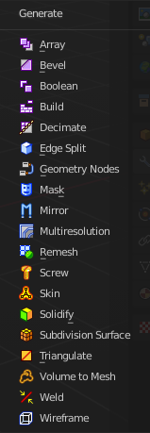

Array
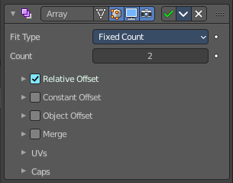
The Array modifier creates an array of copies of the base object. Each copy can offset from the previous one in any of a number of possible ways. Vertices in adjacent copies can be merged if they are nearby, allowing smooth Subdivision Surface frameworks to be generated.
This modifier can be useful when combined with tillable meshes for quickly developing large scenes. It is also useful for creating complex repetitive shapes.
Multiple Array modifiers may be active for an object at the same time. This allows to create complex three-dimensional constructs.
Hint for Offset Calculation. The transformation applied from one copy to the next is calculated as the sum of the three different components (Relative, Constant and Object), each of which can be enabled/disabled independently of the others. This allows, for example, a relative offset of (1.0, 0.0, 0.0) and a constant offset of (0.1, 0.0, 0.0), giving an array of objects neatly spaced along the X axis with a constant 0.1 unit between them, whatever the original object’s size.

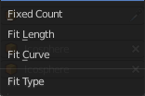
Fit Type
Controls how the length of the array is determined.

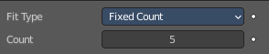
Fixed Count
Generates the number of copies specified in Count.

Fit Length
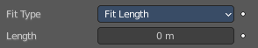
Generates copies to fit within the fixed length given by Length.

Fit Curve
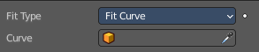
Generates copies to fit within the length of the curve object specified in Curve. You need to select a curve object.
Note! Both Fit Curve and Fit Length use the local coordinate system size of the base object, which means that scaling the base object in Object Mode will not change the number of copies generated by the modifier.
Fit Length uses the local coordinate system length of the curve, which means that scaling the curve in Object Mode will not change the number of copies generated by the modifier.
Applying the scale can be useful for both.

Relative Offset

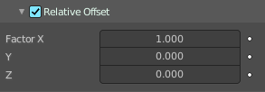
Factor X/Y/Z
Adds a translation equal to the object’s bounding box size along each axis to the offset, multiplied by a scaling factor. X, Y and Z scaling factors can be specified.

Constant Offset

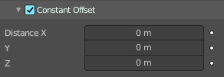
Distance X/Y/Z
Adds a constant translation component to the duplicate object’s offset. X, Y and Z constant components can be specified.

Object Offset
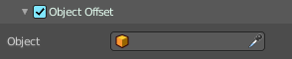
Adds a transformation taken from a chosen object relative to the current object to the offset.

Object
Choose an object.

Merge
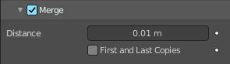
If enabled, vertices in each copy will be merged with vertices in the next copy that are within the given Distance.

Distance
The merge distance between the vertices. Vertices below this distance will be merged.

First and Last Copies
Merge vertices in first and last duplicates.

UV's

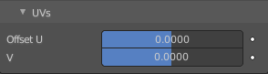
Offset U/V
Shifts UV's of each new duplicate by a settable amount.

Caps

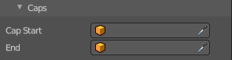
Cap Start / End
Adds a chosen mesh at the start and end of the array. The start object is added at position -1. The end object at position +1. When Merge is activated, and the cap vertices are within the Distance threshold, they will be merged.
Note! The start/end cap objects currently do not support the First and Last Copies option.

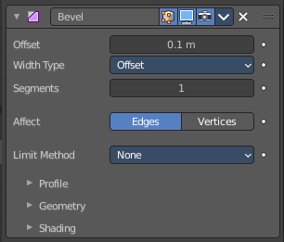
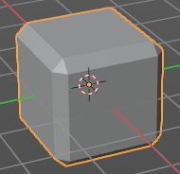
Bevel
The Bevel modifier bevels the edges of the mesh. It is a non-destructive alternative to the Bevel Operation in Edit Mode.

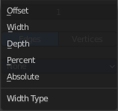
Width Type
Defines how Width will be interpreted to determine the amount of bevel.

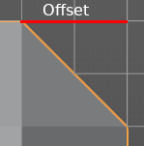
Offset
Value is interpreted as the distance from the original edge to the edge of the beveled face.

Width
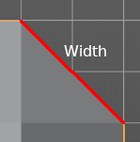
Value is interpreted as the distance between the two new edges formed by the bevel.

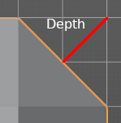
Depth
Value is the perpendicular distance from the new bevel face to original edge.

Percent
Similar to Offset but the value is interpreted as a percentage of the adjacent edge length.

Absolute
Amount is absolute along adjacent edge.

Amount
The bevel amount.

Segments
The number of edge loops added along the bevel’s face.

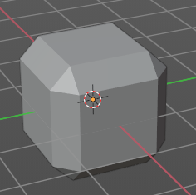
Affect

Edges
Bevels both edges and vertices.

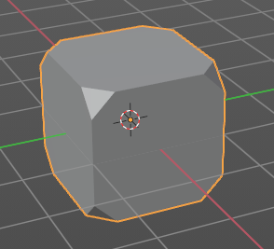
Vertices
Only the areas near vertices are beveled, the edges remain unchanged.

Limit Method
Used to control where a bevel is applied to the mesh.


None
No limit, all edges will be beveled.

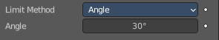
Angle
Only edges where the adjacent faces form an angle smaller than the defined threshold will be beveled. Intended to allow you to bevel only the sharp edges of an object without affecting its smooth surfaces.

Angle
The angle above which to bevel.


Weight
Use each edge’s bevel weight to determine the width of the bevel. When the bevel weight is 0.0, no bevel is applied.

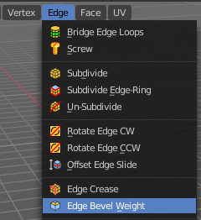
Edge bevel weight can be set in Edit mode in the Edge menu with the Edge Bevel Weight tool.

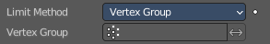
Vertex Group
Use weights from a vertex group to determine the width of the bevel. When the vertex weight is 0.0, no bevel is applied. An edge is only beveled if both of its vertices are in the vertex group. See here about adjusting vertex group weights.

Vertex Group
Choose the vertex group.

Invert
Inverts the influence of the selected vertex group.

Profile
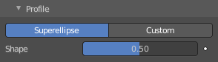
The profile defines the shape of the bevel. Profile has no effect if the number of segments is below 2.

Super Ellipse
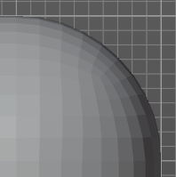
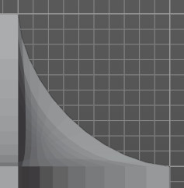
Defines a rounded bevel corner.

Shape
The shape of the rounded bevel corner. A value close to 0 bends the roundness to inside. A value towards 1 bends the curve to outside. A value of 0.5 defines a radius around the center point of the bevel.

Custom
Here you can define a custom shape profile for the bevel.

Miter Shape
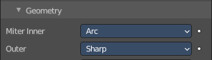
The shape of the custom bevel corner. Has no effect when the miter type is sharp. You need to set it to Arc in the geometry section.

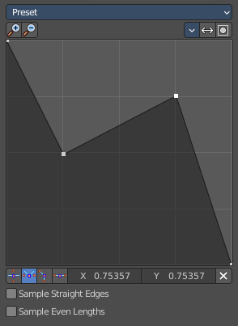
Custom Profile
Choose and adjust a custom bevel profile. This feature needs more than one segment to work.

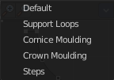
Preset
Choose some profile presets.

Zoom in
Zooms into the curve view.

Zoom out
Zooms out of the curve view.

Tools

Reset View
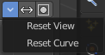
Resets the zoom factor of the curve view.

Reset Curve
Resets the curve to the defaults. This means when you choose a curve preset to reset it to the values of the latest chosen preset.

Reverse Path
The path gets reversed. The first point becomes the last and vice versa.

Toggle Profile Clipping
Toggles the profile clipping.

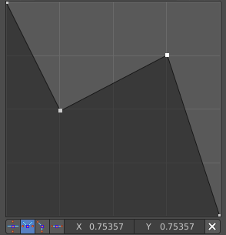
Curve view
Adjust the profile curve.
Left click where no point is adds a new point. Left click at a point allows you to move it.
Holding down Shift while moving a node point activates precision movement.
Holding down ctrl while moving activates temporary snapping.
When a point is selected then the curve view reveals a sub menu at the bottom.

Handle Type Auto Handle
Sets the handle type of this curve point to smooth.

Handle Type Vector Handle
Sets the handle type of this curve point to sharp.

Handle Type Free Handle
Sets the handle type of this curve to Free handles. The curve point has now two handles with which you can adjust the curve before and after the point each.

Handle Type Aligned Free Handle
Sets the handle type of this curve to Free handles. The curve point has now a handle with which you can adjust the curve.

X Y Values
The position of the currently selected curve point.

Delete
Delete the selected curve point.

Sample Straight Edges
Sample edges with vector handles.

Sample Even Lengths
Sample edges with even lengths.

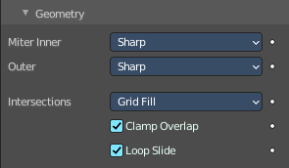
Geometry

Miter Inner
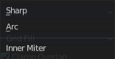
How the inner miter is set. Miter is how the bevel rounding at a corner is done.


Sharp
Creates a sharp miter.

Arc

This replaces the vertex of a miter with 2 vertices, joined by an arc. A separate Spread parameter says how far to move the vertices away from their original position.

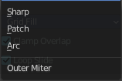
Outer
How the outer miter is set. Miter is how the bevel rounding at a corner is done.

Sharp
Creates a sharp miter.


Patch
This replaces the outside vertex of a miter with 3 vertices. And uses a patch pattern there.

Arc
This replaces the vertex of a miter with 2 vertices, joined by an arc. A separate Spread parameter says how far to move the vertices away from their original position.

Intersections
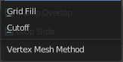
If a bevel corner is filled or not. Needs minimum two segments to have effect.
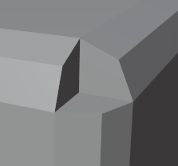
When the inner corners of the cutoff profiles faces meet at the same location with a three way intersection, then no center face is created.
The direction of the cutoff faces depends on the original vertex’s normal.

Clamp Overlap
Limits the width of each beveled edge so that edges cannot cause overlapping intersections with other geometry.

Loop Slide
If there are unbeveled edges along with beveled edges into a vertex, the bevel tries to slide along those edges when possible. Turning the option off can lead to more even bevel widths.

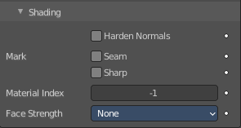
Shading

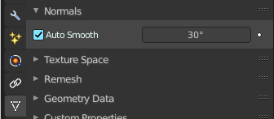
Harden Normals
Match normals of new faces to adjacent faces.
Autosmooth needs to be enabled for this feature. And the shading needs to be smooth.

Mark

Seam
When the beveled edge is a seam edge, then the bevel will also contain a seam to keep the seam into account.

Sharp
When the beveled edge is a sharp edge, then the bevel will also contain a sharp edge to keep the sharp edge into account.

Material Index
The index of the material slot to use for the bevel. When set to -1, the material of the nearest original face will be used.

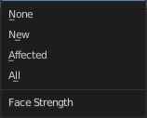
Face Strength
Set the Face Strength on the faces involved in the bevel by the mode specified here.
This face strength then can be used in conjunction with a following Weighted Normals modifier (with the Face Influence option checked).

None
Do not set face strength.

New
Set the face strength of new faces along edges to Medium, and the face strength of new faces at vertices to Weak.

Affected
In addition to those set for the New case, also set the faces adjacent to new faces to have strength Strong.

All
In addition to those set for the Affected case, also set all the rest of the faces of the model to have strength Strong.

Boolean
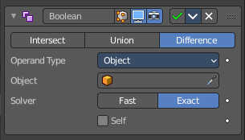
The Boolean modifier uses one of the three available Boolean operations to create a single mesh out of two mesh objects. Union, Difference and Intersect. This modifier needs a second object to be the target of the operation.
Boolean operations may or may not deliver useful results. And requires nearly always manual cleanup afterwards since it tends to create N-Gon geometry and can create micro triangles. You should also avoid co-planar faces. Manifold meshes works best.
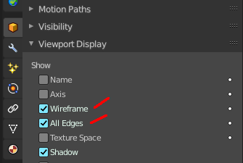
Tip! Tick Wireframe, and All Edges in the Viewport Display panel to see the bool result in realtime happen. And hide the bool object. That way you can tweak the positions of the objects if needed.

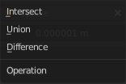
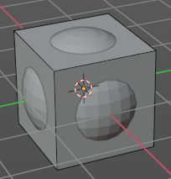
Operation
The Boolean operation to use.
Demonstrated at a cube with the modifier applied, and a sphere as the target object.

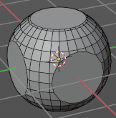
Intersect
Keeps the intersecting geometry, removes the non intersecting geometry.

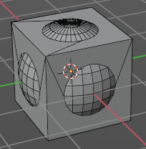
Union
The target mesh is added to the modified mesh.

Difference
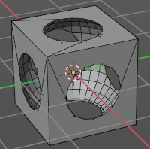
Keeps the non intersecting geometry, removes the intersecting geometry.

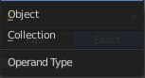
Operand Type

Object
The target mesh object. You need to choose a target mesh object for the boolean operation.

Solver
Fast or Exact.

Overlap Threshold
The threshold for overlapping geometry. This value determines above which value a boolean operation happens.

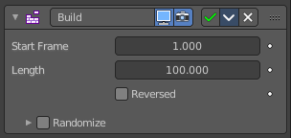
Build
The Build modifier lets the faces of the mesh object to appear or disappear one after the other over time when you play the animation.

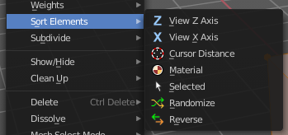
By default, faces appear in the order in which they are stored in memory, which follows the order how they are created. This face/vertex order can be altered in Edit Mode by using Sort Mesh Elements in the Mesh menu.

Start
The start frame of the building process.

Length
The number of frames over which to rebuild the object.

Reversed
The modifier will operate in reverse, and start with the full mesh. And deconstruct it towards the end frame.

Randomize
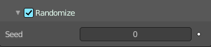
Randomizes the order in which the faces are built.

Seed
The random seed. Changing this value gives a different “random” order when Randomize is checked. This order is always the same for a given seed/mesh set.

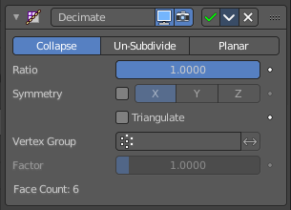
Decimate
The Decimate modifier allows you to reduce the vertex/face count of a mesh with minimal shape changes. The result is just displayed in Object mode. In Edit mode the unaltered mesh is shown.

Mode

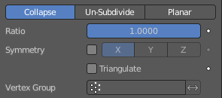
Collapse
This algorithm uses progressive merging of vertices, taking the shape of the mesh into account.

Ratio
The ratio of faces to keep after decimation. 1.0 is not altered. The lower the value the stronger the reduction.
Note! Although the Ratio is directly proportional to the number of remaining faces, triangles are used when calculating the ratio.
This means that if your mesh contains quads or other polygons, the number of remaining faces will be larger than expected, because those will remain unchanged if their edges are not collapsed.
This is only true if the Triangulate option is disabled.

Symmetry
Maintains symmetry on a single axis.

Triangulate
Keeps any resulting triangulated geometry from the decimation process.

Vertex Group
A vertex group that controls what parts of the mesh are decimated.

Invert
Decimate the geometry except the vertex group.

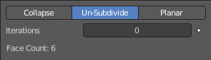
Un-Subdivide
This algorithm tries to unsubdivide divided faces.

Iterations
The number of times to perform the unsubdivide operation. Two iterations is the same as one subdivide operation, so you will usually want to use even numbers.

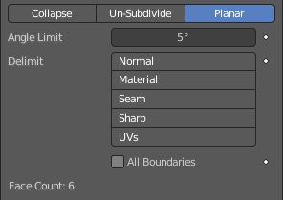
Planar
This algorithm reduces details by unioning adjacent faces that are below an angle limit.

Angle Limit
Dissolve geometry which form angles (between surfaces) higher than this setting.

Delimit
Prevent dissolving geometry in certain places.

Normal
Does not dissolve edges on the borders of areas where the face normals are reversed.

Material
Does not dissolve edges on the borders of where different materials are assigned.

Seam
Does not dissolve edges marked as seams.

All Boundaries
When enabled, all vertices along the boundaries of faces are dissolved.

Face Count
The face count of the decimated mesh.

Edge Split
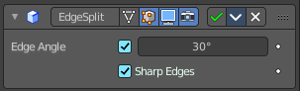
The Edge Split modifier splits single edges into two independent edges when the adjacent faces are below the defined angle. Or when the edge is marked as sharp. Which can be done in edit mode in the Edge menu with the Mark Sharp tool.
Splitting an edge affects vertex normal generation at that edge, and makes the edge appear sharp. So this modifier can be used to achieve the same effect as Auto Smooth. And make edges appear sharp when their angle is above a certain threshold. It can also be used for manual control of the smoothing process, where the user defines which edges should appear smooth or sharp (see Mesh Smoothing for other ways to do this). If desired, both modes can be active at once.
Note! This modifier is kept mostly for historical/compatibility reasons. Everything it can do in shading, and much more, can now be achieved using custom normals. Unless you really need the topology changes it generates, it is not advised to use it in new projects.

Edge Angle
The angle above which to split edges.

Sharp Edges
When you have marked edges as sharp, then these edges will be split.
Note! Non-manifold edges will always be split.

Geometry Nodes
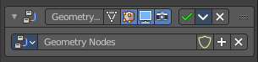
The geometry Nodes modifier adds a geometry node tree, which can be modified in the geometry node editor.

Manage the nodes. If there is no geometry node tree for the current object, then you will see the New button

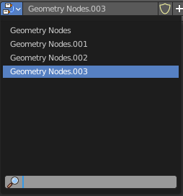
Data Browser
The list of available geometry node trees in the scene.

Edit box
The name of the current active geometry node tree. Here you can also rename the node tree.

Add Fake User
Wit this button you assign a fake user to this selected geometry node tree.
Data, like node trees, that is not longer linked to anything else gets removed when you save and reload a scene. Bforartists has the concept of fake users to go around this behavior. An image with a fake user is in fact linked to something. And so it is not lost when you save and reload the scene.

User
The number of users that uses this data. Data with a user number of 0 will be removed with closing Bforartists.

Add
Add a geometry node.

Remove
Removes the geometry node tree. To delete it completely you need to purge it. See Fake user.

Mask
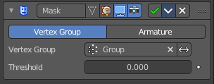
The Mask modifier allows to hide vertices of an object dynamically based on vertex groups or an Armature.

Mode
Use Vertex Groups or an armature to hide the mesh Vertex Group works in Object mode. Armature works in Pose mode, and uses the active bone for masking.

Vertex Group
Here you can select the vertex group that you want to use for masking. The geometry from this vertex group is shown.

Armature
When in Pose Mode, vertices belonging to the vertex group associated with the active bone (same names) will be visible. Vertices not in that group will be hidden.

Invert
Show the not selected geometry instead of the selected.

Threshold
Vertices with weights less or equal to this value will be hidden.

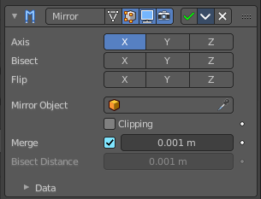
Mirror
The Mirror modifier mirrors a mesh along its local X, Y and/or Z axes, across the Object Origin. It can also use another object as the mirror center, then use that object’s local axes instead of its own.

Workflow
Usually this modifier is used for mirror modeling in edit mode. In Edit mode just the original side is editable then. Recommend is to remove half of the mesh before starting. The missing part will then be added by the Mirror modifier. But you can also use the Bisect feature.

Axis
The axis to mirror along.
You can select more than one of these axes. And will then get more mirrored copies. With one axis you get a single mirror, with two axes four mirrors, and with all three axes eight mirrors.

Bisect
If the mesh is already on both sides of the mirror plane, it is cut by that plane. And only one side (the “negative” one by default) is kept to perform the mirror process.
Note. When you turn Bisect on and pull at the mirror part, then you won't have the mirroring effect to the original side.

Flip
When Bisect is enabled on an axis, you can use this setting to switch the side kept and mirrored (i.e. when it is enabled, the “positive” side will be kept, instead of the “negative” one).

Mirror Object
An Object Selector to select an object (usually an empty), which position and rotation will be used to define mirror planes (instead of using the ones from the modified object).
You can animate it to move the mirror axis.

Clipping
Prevents vertices from moving through the mirror plane(s) when you transform them in Edit Mode.
If it is enabled but vertices are beyond the mirror plane and outside of the Merge Distance, the vertices will not be merged. But as soon as the vertices are within Merge Distance they are snapped together and cannot be moved beyond the mirror plane.
Note! Vertices on the mirror plane will be unable to move away from the mirror plane as long as Clipping is enabled. You must disable it to be able to move the vertices along the mirror axis again.

Merge
Where a vertex is in the same place (within the Merge Distance) as its mirror it will be merged with the mirrored vertex.

Bisect Distance
Vertices are removed up to this distance from the bisect plane.

Merge Distance
The maximum distance between a vertex and its mirror copy at which they are merged together (being snapped on the mirror plane). Needs Merge to be enabled.

Data

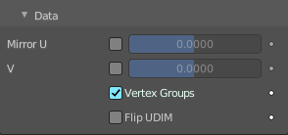
Mirror UV
Mirror the UV texture coordinates across the middle of the image.

Vertex Groups
Try to mirror existing vertex groups.
Note! The vertex groups you want to mirror must be named following the usual left/right pattern (i.e. with suffixes like “.R”, “.right”, “.L”, etc.). The mirror side vertex group must already exist (it will not be created automatically). It must also be completely empty (no vertices assigned to it).

Flip UDIM
Mirror the texture coordinates around each tile center.

Multiresolution
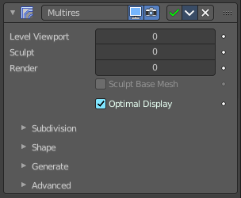
The Multiresolution modifier, in short “Multires”) allows you to subdivide a mesh similarly to the Subdivision Surface modifier, but also allows you to edit the new subdivision levels in Sculpt Mode.
Note! Multiresolution cannot be re-positioned in the stack after any modifier that will change geometry or other object data (This means all Generate, some Modify and some Simulate modifiers cannot come before the Multiresolution modifier). It needs to work at the unaltered base mesh.

Workflow
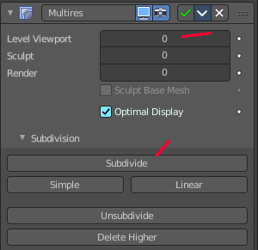
Add the modifier. Switch to Sculpt mode. Click at the Subdivide button. The Levels sculpt slider will now turn to 1. Do some sculpting. Click at the Subdivide button again. The Levels sculpt slider will now turn to 2. You have added a second sds layer now. Do some sculpt now. Click at the Subdivide button again, and you have a third sds sculpting level. Do some sculpt now.
To work at level 1 SDS simply change the Levels sculpt value back to 1. Or to 2 when you want to work at layer 2.

Level Viewport
Number of subdivisions in the viewport when not in sculpt mode.

Sculpt
Number of subdivisions to use in sculpt mode.

Render
Number of subdivisions when rendering the image.

Sculpt at Base Mesh
Sculpt at the base mesh, not at the multires sds layer.

Optimal Display
In object mode the subdivided edges will not be drawn. Only the edges of the base geometry.

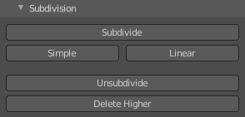
Subdivision Subpanel

Subdivision Mode

Subdivide
Adds another layer of subdivision. This subivision method divides the mesh smooth with the catmull clark algorithm.

Simple
Adds another layer of subdivision. The simple method just divides the existing faces.

Linear
Adds another layer of subdivision. The linear method divides the existing faces and interpolates linear.

Unsubdivide
Removes all subdivision layers.

Delete Higher
Removes the highest subdivision layer.

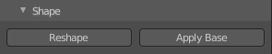
Shape subpanel

Reshape
Copies vertex coordinates from another mesh.
Usage: first select a different mesh object with matching topology and vertex indices. Shift select the object you wish to copy vertex coordinates to. Click Reshape.

Apply Base
Modifies the original unsubdivided mesh to match the form of the subdivided sculpted mesh.

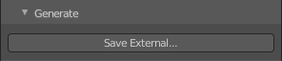
Generate Subpanel

Save External / Pack External
Saves displacements to an external .btx file. The Multiresolution sds information is then stored externally, so that the blend files doesn't become too big.

File path
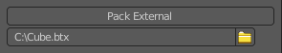
Once saved you will see the path to the btx file below the save external button. The save external button has turned into Pack external then.

Type
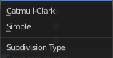
Sets the type of subdivision. Note! You need to set the subdivision type before you start. You can't change it afterwards.

Catmull-Clark
Creates a smoothed surface, using the standard Catmull-Clark subdivision surface algorithm.

Simple
Maintains the current shape, and simply subdivides edges.

Levels Sculpt
The subdivision layer.

Viewport
Set the level of subdivisions to show in Object Mode. In Sculpt mode this value has no effect.

Render
Set the level of subdivisions to show when rendering.

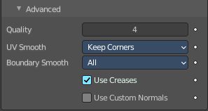
Advanced Subpanel

Quality
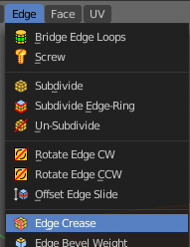
How precisely the vertices are positioned. This settings becomes active when you have an edge crease applied. This can be done in edit mode in the edge menu.

UV Smooth
How to handle UV's during subdivision.

Smooth, keep corners
UV islands are smoothed, but their boundary remain sharp.

Sharp
UV remain unchanged.

Use Creases
Use the crease information. This settings becomes active when you have an edge crease applied.

Remesh
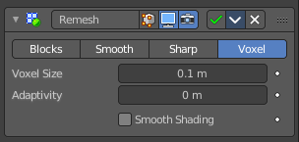
The Remesh modifier generates new mesh topology. The output follows the surface curvature of the input. But its topology contains quads.
The output and also the settings of the three basic modes Blocks, Smooth and Sharp is almost identical. Except the smoothing.

Blocks, Smooth, Sharp
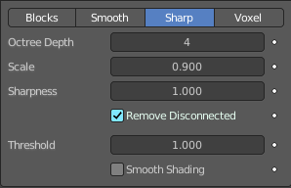
Blocks has no smoothing at all. Smooth outputs a smooth surface. Sharp outputs a smooth surface but preserves sharp edges and corners.

Octree Depth
The resolution of the Octree. Higher values gives finer details.

Scale
The ratio of the largest dimension of the model over the size of the grid.

Sharpness
Sharp mode only. Tolerance for outliers. Higher values produce edges more similar to the input, while lower values filter out noise.

Remove Disconnected
Filter out small disconnected pieces of the output.

Threshold
Use this to control how small a disconnected component must be to be removed.

Smooth Shading
Output faces with smooth shading. The smooth/flat shading of the input faces is not preserved.

Voxel
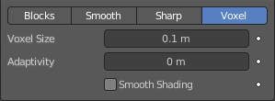
Generate a new manifold mesh from the current geometry while trying to preserve the mesh’s original volume.

Voxel Size
The voxel size. Defines the resolution of the created mesh.

Adaptivity
Reduces the final face count by simplifying geometry where detail is not needed. This feature triangulates faces that do not need as much detail.

Smooth Shading
Output faces with smooth shading. The smooth/flat shading of the input faces is not preserved.

Screw
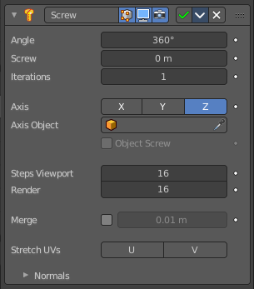
The Screw modifier takes a profile object, a mesh or a curve, to create a helix-like shape.
The profile should be properly aligned to the cardinal direction of the object.

Angle
Degrees for a single helix iteration.

Screw
Offsets the iteration along its axis.

Iterations
Number of iterations.

Axis
The axis along which the helix will be built.

Screw
The height of one helix iteration.

Axis Object
Pick an object to define the axis direction. The helix will then point into the direction of this object.

Object Screw
Use the distance from the Axis Object to define the height of one helix iteration.

Steps Viewport
Number of steps used for a single revolution displayed in the 3D Viewport.

Render
Number of steps used for a single revolution used during render time. Higher values gives higher quality.

Merge
Merge vertices that lie on the axis of rotation. Closes off end points with a triangle fan.

Merge Distance
Vertices under this distance to the axis are merged.

Stretch UV's
Stretch the UV coordinates from (0.0 to 1.0) when UV's are present.

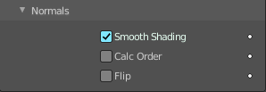
Normals

Smooth Shading
Output faces with smooth shading. The smooth/flat shading of the input geometry is not preserved.

Calculate Order
Order of edges is calculated to avoid problems with normals and shading. Only needed for meshes, not curves.

Flip
Flip normals direction.

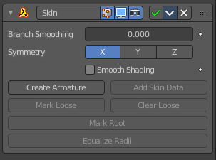
Skin
The Skin modifier uses vertices and edges to create a skinned surface. The output is mostly quads. But intersections can also produce triangles.
You can use geometry with faces as the base geometry. But the modifier just uses the vertices and edges information.

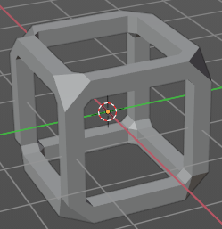
Note! Faces in the original geometry are ignored. The modifier works with the edges and vertices of the geometry. The faces of a cube for example gets removed. The new geometry appears around the edges.

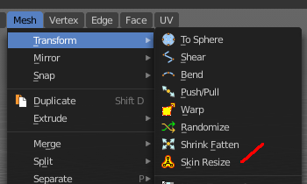
Note! The thickness of the created geometry can be adjusted in Edit mode with the Skin Resize tool.

Note! The Edit mode also activates most of the in Object mode greyed out tools.

Branch Smoothing
A branch point is a vertex with three or more connected edges. These areas tend to produce more complicated topology, some of which may overlap. This setting relaxes the surface around these points, with the side effect of shrinking it.

Symmetry Axes X/Y/Z
Keep the output topology symmetrical in their here chosen axes.
Note! They do not add geometry flipped across an axis. For that, the Mirror modifier should be used, typically placed above the Skin modifier.

Smooth Shading
Output faces with smooth shading rather than flat shading. The smooth/flat shading of the input geometry is not preserved.

Create Armature
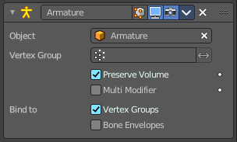
Creates an armature modifier below the Skin modifier. Each edge becomes a bone. And the generated mesh of the Skin modifier is assigned to this armature, with automatic weights. Deforming the armature will then deform the mesh.
Note! If the root vertex has more than one adjacent edge, an extra bone will be created to serve as the root.

Add Skin Data
The Skin modifier uses a custom set of data in the mesh. This data is generated automatically when you add the Skin modifier the first time. There are use cases where this data can get lost, and the Skin modifier quits working. Add Skin Data then becomes available, and you can update the data.

Mark / Clear Loose
You need to be in Edit Mode to make this tool active.
By default, a branch vertex (vertex with three or more connected edges) will generate extra edge loops along adjacent edges in order to keep the output tight. Branches can be made loose by clicking Mark Loose, which will allow the output to stretch between all adjacent vertices. This can be disabled again by clicking Clear Loose.

Mark Root
You need to be in Edit Mode to make this tool active.
Marking a vertex as root causes that vertex to be used for calculating rotations for connected limbs. Root vertices also affect the armature output, they will be used as the origin for the root bones.
Each set of connected vertices should have one root node (one is selected by default if you do not assign any manually). Mark Root enforces the one-root per set rule, so it is not necessary to manually unmark roots.

Equalize Radii
You need to be in Edit Mode to make this tool active.
Makes the skin radii of selected vertices equal on each axis.

Solidify
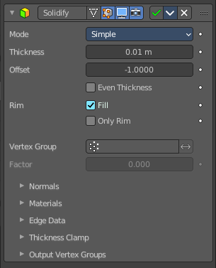
The Solidify modifier adds depth and thickness to the faces of a geometry.
Example. A cube with one face removed.
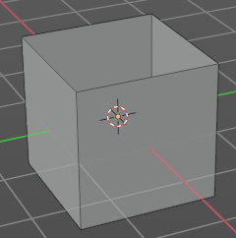
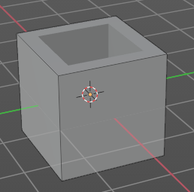

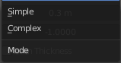
Mode

Simple
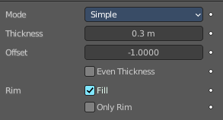
This algorithm simply extrudes the geometry. It does not work on geometry where edges have more than two adjacent faces.
Important! Simple mode will not be able to solidify the boundary between two adjacent faces that does not point into the same direction.

Thickness
The extrude amount.

Offset
A value between (-1 to 1) to locate the solidified output inside or outside the original mesh. The inside and outside is determined by the face normals. Set to 0.0, the solidified output will be centered on the original mesh.

Even Thickness
Maintain the thickness by adjusting for sharp corners.
Note! Solidify thickness is an approximation. The final wall thickness is not guaranteed. The best option to preserve wall thickness is complex mode with constraints thickness mode. But even this is not guaranteed to work perfect in every case.

Rim
Note! Fill and Only Rim only make a difference on Non-manifold objects, since the rims are generated from the borders of the original geometry.

Fill
Fills the gap between the inner and outer edges.

Only Rim
Will not extrude surfaces parallel to the original one, but instead will only add the perpendicular rim.

Complex
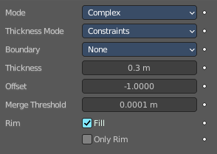
This solidify algorithm can handle every geometric situation to guarantee a manifold output geometry. It is able to solidify shapes like Möbius strips, Klein bottles, architectural wall layouts and many more which the Simple Mode isn’t able to do.
If the special cases are not present it is recommended to choose Simple because the extra logic makes this algorithm much slower.
Note! There are no options for crease in the Modifier tab because crease is handled in a dynamic way. The modifier will transfer the creases of the original mesh in a smart way to the output mesh to work with the Subdivision Surface modifier.

Thickness Mode
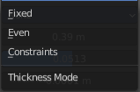
Choose the kind of thickness handling.

Fixed
The new vertices are always in a fixed distance to the old ones.

Even
Adjusts for sharp corners, but may not always work when more than three faces come together.

Constraints
For up to three faces it is always guaranteed to find an optimal solution.

Boundary
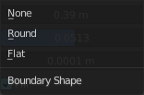
Choose the kind of boundary handling.

None
No boundary fix is applied. Results are stable.

Round
Adjusts the boundary for an opening to face inwards (like a hole in an egg).

Flat
Adjusts the boundary of a planar opening to be a flat (like a cut sphere).

Thickness
The extrude amount.
Important! The modifier thickness is calculated using local vertex coordinates. If the object has a non-uniform scale, the thickness will vary on different sides of the object. To fix this, either Apply or Clear the scale.

Offset
A value between (-1 to 1) to locate the solidified output inside or outside the original mesh. The inside and outside is determined by the face normals. Set to 0.0, the solidified output will be centered on the original mesh.

Merge Threshold
The distance within which degenerated geometry is merged.

Rim
Note! Fill and Only Rim only make a difference on Non-manifold objects, since the rims are generated from the borders of the original geometry.

Fill
Fills the gap between the inner and outer edges.

Only Rim
Will only leave the generated perpendicular rim
Note! Fill and Only Rim only make a difference on Non-manifold objects, since the rims are generated from the borders of the original geometry.

Vertex Group
Only vertices in this group are solidified. Their weights are multiplied by the thickness, so vertices with lower weights will be less thick.

Invert
Reverses the vertex group, so that only vertices which are not in the vertex group are solidified.

Factor
How much the vertex weights are taken into account. You need to have a vertex group assigned to activate this item.
On 0.0, vertices with zero weight will have no thickness at all (creates duplicate vertices).
On 0.5, vertices with zero weight will be half as thick as those with full weight.
On 1.0 , the weights are ignored and the Thickness value is used for every vertex.

Flat Faces
Just in Complex Mode. Use the minimal vertex weight assigned to the vertices of a face to make sure that new faces stays parallel to their original ones. This is slow, so disable it when it is not needed.

Normals

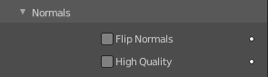
Flip Normals
Reverse the normals of all geometry (both the inner and outer surfaces).

High Quality Normals
Just Simple Mode. Normals are calculated to produce a more even thickness.

Materials

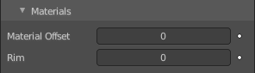
Material Offset
Choose a different material for the new geometry. This is applied as an offset from the original material of the face from which it was solidified.
A value of 0 means it will use the same material.
A value of 1 means it will use the material immediately below the original material.
A value of -2 means the material two positions above the original material will be used.
These values are clamped to the top-most and bottom-most material slots.

Rim
Choose a different material for the rim faces.

Edge Data
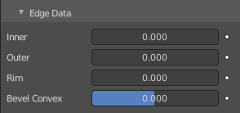
Inner, Outer and Rim are simple mode only.

Inner
Set a crease to the inner edges.

Outer
Set a crease to the outer edges.

Rim
Set a crease to the rim.

Bevel Convex
Edge bevel weight to be added to outside edges.

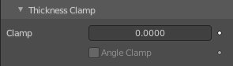
Thickness Clamp

Clamp
A value between (0 to 2) to clamp offsets to avoid self-intersection. The amount is determined by the length of the shortest adjacent edge.

Angle Clamp
If enabled clamping will also consider angles in the geometry, not only lengths. Becomes active when the clamp value is above 0.0.

Output Vertex Groups

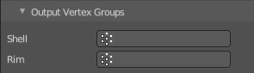
Shell
Vertex group that the generated shell geometry will be weighted to. This allows you to use other modifiers to only affect the shell geometry by using a that modifier’s vertex group influence control.

Rim
Same as Shell Vertex Group, but for the generated rim geometry.

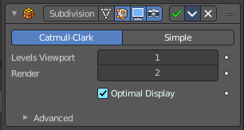
Subdivision Surface
The Subdivision Surface modifier subdivides the faces of the mesh. With Simple it just divides the faces. The Catmull-Clark algorithm allows you to smoothen the result.

Type

Catmull-Clark
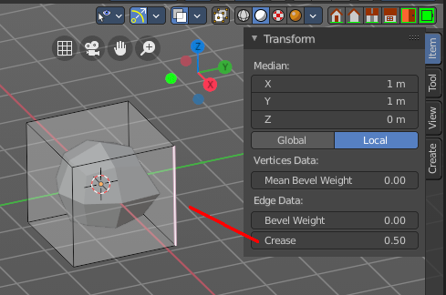
Subdivides and smooths the surfaces.
Note! Catmull-Clark subdivision rounds off edges. And sometimes this is not what you want. There are several solutions that allow you to control the subdivision. You can add a so called support edge or a support loop to keep the edge sharp.
Or you can change the crease of the edges in question. Edge Crease can be adjusted in the Transform panel in the Item tab of the sidebar in the 3D view. You need to be in Edit mode.
Note! Abrupt normal changes in the surface can produce ugly black gouges, even when these flipped normals are not an issue for the shape itself. A quick way to fix this is to use the Recalculate Normals operation in Edit Mode. If you still have some ugly black gouges you can try to manually flip the normals in question.

Simple
Only subdivides the surfaces, without any smoothing.

Levels Viewport
The number of subdivision levels shown in the 3D Viewport.

Render
The number of subdivision levels shown in the final render.

Optimal Display
When rendering the wire frame of this object, the wires of the new subdivided edges will be skipped. Only the edges of the original geometry will be displayed.

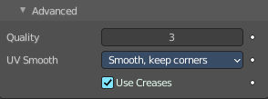
Advanced

Quality
How precisely the vertices are positioned, relatively to their theoretical position of an infinitely subdivided mesh.
Note! This value can have an affect on how accurate Edge Creases can be. Using a higher Quality value will allow for a wider range of crease values to work accurately.

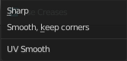
UV Smooth
How to handle UV's during subdivision.

Smooth, keep corners
UV islands are smoothed, but their boundary remain sharp.

Sharp
UV remain unchanged.

Use Creases
Use the Weighted Edge Creases values stored in edges to control the smoothness of the edges.

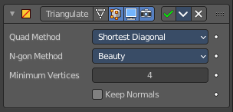
Triangulate
The Triangulate modifier triangulates all faces in a mesh.

Quad Method
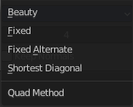
How to triangulate quads.

Beauty
Tries to split the quads in a way that takes the topology into account.

Fixed
Split the quads on their 1st and 3rd vertices.

Fixed Alternate
Split the quads on their 2nd and 4th vertices.

Shortest Diagonal
Split the quads based on the diagonal distance between their vertices.

Polygon Method
How to triangulate N-Gons.

Beauty
Tries to split the N-Gons in a way that takes the topology into account.

Clip
Split the N-Gons by using an ear-clipping algorithm

Minimum Vertices
Minimum number of vertices a face must have to be triangulated. For example, setting this value to 5, will prevent triangulation of Quads and only triangulate N-gons.

Keep Normals
When using custom normals, try to preserve the same shading as before triangulation.

Volume to mesh
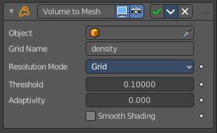
This modifier is the inverse of the Mesh to Volume modifier. It takes an existing volume object and converts one of its grids to a mesh. Only scalar grids (such as the density grid) can be converted.
Tip! To copy and move the generated mesh separately from the volume object, use a collection instance.

Object
The source volume object. Pick the volume object here.

Grid Name
The name of the grid to convert. The grid has to be a scalar grid.

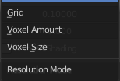
Resolution Mode
How the resolution of the final mesh is controlled.

Grid
This makes the resolution dependent on the resolution of the grid that is converted. Higher resolution grids result in a higher resolution mesh. In many cases, that is the most efficient mode.

Voxel Amount
Specifies the approximate resolution of the final mesh. The voxel size is adapted to the size of the entire volume.

Voxel Size
Use a fixed resolution that does not change when the volume changes.

Threshold
Voxels with a larger value are considered to be inside the mesh and all other voxels outside. The mesh will be generated on the boundary of inside and outside voxels. This is sometimes also called the “iso value”.

Adaptivity
This is similar to decimating the final to reduce resolution where it is not needed.

Smooth Shading
Enables smooth shading on the generated mesh.

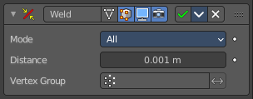
Weld
The Weld modifier merges vertices within a threshold.

Mode

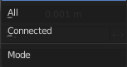
All
Full merge by distance.

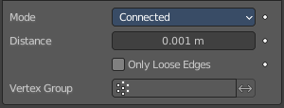
Connected
Just along the edges.

Distance
The maximum distance to merge vertices.

Only Loose Edges
Just with Connected. Welds only loose edges.

Vertex Group
Only merge vertices from this vertex group.

Invert
Inverts the influence of the selected vertex group. Only vertices outside of this vertex group will be merged.

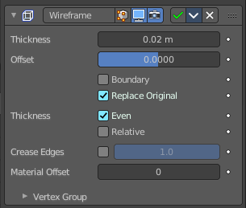
Wireframe
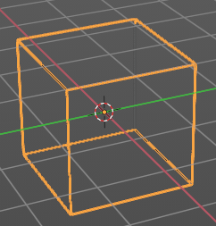
The Wireframe modifier hides the faces of a mesh, and turns the edges into four sided polygon geometry. The result then looks like you would have a wire frame view of the mesh.
The mesh needs to have faces.

Thickness
The depth or size of the wire frames.

Offset
A value between (-1 to 1) to change whether the wire frames. are generated inside or outside of the original mesh. Set to zero, Offset will center the wire frames. around the original edges.

Boundary
Creates wire frames. on mesh island boundaries.

Replace Original
Replace the original mesh by the generated wire frame mesh. If not, the wire frame is generated on top of it.

Thickness
Warning! Wireframe thickness is an approximation. While Even Thickness should yield good results in many cases, skinny faces can cause ugly spikes. In this case you can either reduce the extreme angles in the geometry or disable the Even Thickness option.

Even
Maintain thickness by adjusting for sharp corners. Sometimes improves quality but also increases computation time.

Relative
Determines the edge thickness by the length of the edge. Longer edges will be thicker.

Crease Edges
This option is intended for usage with the Subdivision modifier. Enable this option to crease edges on their junctions and prevent large curved intersections.

Crease Weight
Define how much crease (0 to 1, nothing to full) the junctions should receive.

Material Offset
Uses the chosen material index as the material for the wire frame; this is applied as an offset from the first material.

Vertex Group
Restrict the modifier to only this vertex group, and use its weighting for thickness.

Invert
Inverts the vertex group weights.

Factor
Percentage that the vertex has influence over the final wire frame result.

